Dhirender Kumar
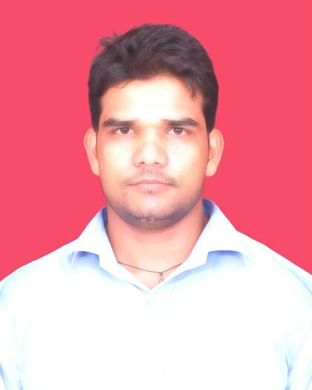
E-Mail ID: -dhirukumar13@gmail.com
: - +91- 9891958784
______________________________________________________________________________________

Objective | To give best of me to my company.
Education | 2010 - 2013 Dr. BhimRao Ambedkar University  (Agra, Uttar Pradesh )  B.A. (Bachelor in Arts)  I have completed my B.A. from Agra University.  Doeacc ‘O’ Level  I have done From JLJ Institute from Faridabad.
Job Experience | - At present I am working in ROHAN MOTORS (Maruti Suzuki) as Team Leader in Palwal (Delhi NCR) from 01.06.13 to till now.  - I have worked in AUTO VIKAS (Chevrolet) as Team Leader in New Delhi from 03.10.08 to 31.12.10.  - I have worked in BATRA MOTORS (Maruti Suzuki) as Sr. Sales Executive in Faridabad from 03.07.06 to 25.09.08.
Summary of qualifications | Senior Secondary Examination (10+2)  (Haryana School of Education Board)  2004 – 2005 Kurukshetra Sr. Sec. School  Faridabad, Haryana.  - Passed in Second Division with 59% Marks.  Matriculation Examination (10th)  (Haryana School of Education Board)  1999 – 2002 Kurukshetra Sr. Sec. School  Faridabad, Haryana.  - Passed in Second Division with 56% Marks.
Languages | Hindi, English.
Hobbies | Cricket, Playing Chess, Netsurfing and Traveling.
Computer Knowledge | Ms-Word, Ms-Excel, Ms-Dos and Internet.
Assets | I am working, Loyal and sincere in my work, always willing to accept new challenge, Has always interested in learning new things and open for accepting new atmosphere and styles.
Personal Details | Date of Birth: 13th October. 1984.  Father’s Name: Sh. Chandeshwer Singh.  Mother’s Name: Smt. Malti Devi  Salary: 19000 INR Per Month.  Address: H. No. E – 227, Air force Road, Dabua Colony,  N. I. T. Faridabad, Haryana – 121001.

(Dhirender Kumar)

